General Meeting
October 1st, 2020 at 4:00 PM
Outside at Emigrant Outpost

-MINUTES-

PEOPLE PRESENT: (40 people present) Did not have folks sign in their names due to Covid 19 precautions

Call meeting to order, Welcome/Introductions – Druska Kinkie, Co-Chair
Made statement about TU water objections in Mill Creek and how the UYWG has come along way since the efforts to resurrect the group began in 2017. The UYWG will continue to work together, create opportunity, and support the priorities of the UYWG

Coordinator Comments, Ashley Lowrey
Meeting structure and agenda, Covid, Advisory Committee.
Thanks for coming and apologies for delay in meeting, challenges with Covid. But it has been a busy summer for the UYWG. We have four main project focus areas right now and will be providing updates of each. 1) Drought resiliency and monitoring efforts, 2) Recreation and River Use data collection and planning, 3) TIP/NRCS, Collaborative Weed Management Project, 4) Development of working lands committee.

New FWP Area Wildlife Biologist Introduction – Michael Yarnall –
Introductions and hello.

Drought Resilience and Monitoring Project – Sara Meloy & John Lunzer (DNRC)
See attached project description sheet below.

Wildlife/Highway Update – Daniel Anderson
Taking a collaborative approach to the conversation of wildlife collisions and crossings with all invested stakeholders and local citizens.

Working Lands Report – Brian Yablonski (PERC)
Elk in Paradise – Next Steps:

Landowner Coordination & Outreach
- Establish a Paradise Valley Working Lands Group
- Tell the story of ranching and recognize its benefits to community and wildlife
- Engage landowners as full shareholders in wildlife management decisions
- Change the message and the messenger

Financial Incentives
- Work to develop a brucellosis risk-transfer tool
- Enter into wildlife-use agreements, or “elk rents”
- Establish a elk compensation funs
- Offer priority or transferable hunting tags to landowners who provide wildlife habitat
- Develop new funding sources to support wildlife conservation on working lands
- Increase the amount of private lands available for public access through negotiation

Research and Technical Assistance:
- Engage MSU Extension, FWP, and others in generating applied research, citizen science, and best practices that help landowners with wildlife
- Integrate landowners knowledge or citizen science into research and data
- Provide regulatory and management flexibility

Recreation Planning and Data collection update – Whitney Tilt
Summer data synthesis – no West Creek symposium this year to discuss results but will find a future time to - next year at West creek perhaps? Use was very up this year.

NRCS TIP update, Weed Management – Dave Molebash & Ashley Lowrey
Tip has been approved and ready for applications.

Public Comment
Alan Redfield made motion to approve minutes, Jessica Mayo-Anderson Second, motion passed.

ADJOURN

5:30-6:00 Social time!

Upper Yellowstone Watershed Study
Informing local, voluntary water supply decisions with a science-based water balance

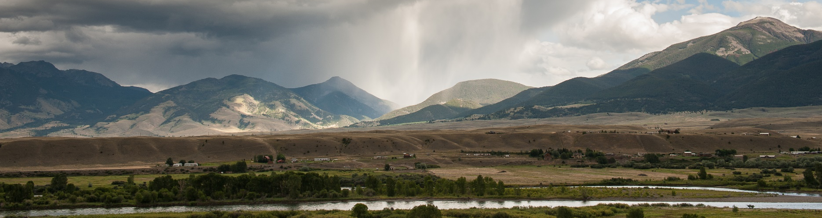

BACKGROUND: Through years of extensive information-gathering and discussion, stakeholders in the Upper Yellowstone River watershed have identified the need to better understand water inputs and outputs in the watershed (a water balance). Development of a water balance along with improved water monitoring is an essential tool to help build watershed resilience.

PROJECT AREA, TIMELINE & PARTNERS: The project area extends from the Yellowstone National Park Boundary to the confluence of the Yellowstone and Shields Rivers. The timeline for this project is 2020 – 2023. Partners include MT DNRC’s Water Management Bureau in collaboration with the Upper Yellowstone Watershed Group, local citizens, NRCS, the City of Livingston, the Montana Bureau of Mines and Geology, Montana Fish, Wildlife & Parks, the National Park Service and the University of Montana Climate Office.
THE PROJECT GOAL is to develop a water balance model that can serve as a streamflow forecasting and management scenario simulation tool. The model will help the watershed community prepare for droughts and floods as well as understand impacts of voluntary water supply decisions at individual and watershed scales.

PROJECT DESCRIPTION:
Define a Water Balance: A water balance essentially records existing water inputs and outputs in the watershed. It provides a fundamental understanding of watershed hydrology that can aid efforts such as drought planning and guide voluntary water supply decision-making.

Improve Monitoring: This project will enhance existing water supply and water use monitoring by installing stream gages on tributaries; increasing monitoring of surface water temperature and precipitation; gathering groundwater data; and improving monitoring of soil moisture, wind speed and relative humidity. Data collection will focus on water use by sector at the watershed scale and will not examine individual water use. For example, data collection on irrigation systems will be grouped into total irrigation and individual irrigation system use will not be depicted in the water balance.

Run Predictive Management Scenarios: A water balance model can be used by the community as a tool to consider hypothetical (but realistic) changes in water supply and use and to weigh the outcomes of water supply decisions such as upgrading irrigation infrastructure or restoring a stream channel. It can also outline impacts from changes in water availability such as low snowpack or extended drought.

Forecast River Flow: Data from stream gages is currently used in other Montana watersheds to forecast future streamflow conditions. This is helpful in flagging future droughts or floods which could inform voluntary preparation on the part of individuals, the watershed group or municipalities.

HOW TO GET INVOLVED:
Local citizens and stakeholders are encouraged to get involved in the project in several ways:
1) Weigh in on the monitoring plan (monitoring locations, schedule, etc.) 2) Join hydrologists in the field to measure water (starting in 2021); 3) Attend Upper Yellowstone Watershed Group meetings for regular project updates and to offer feedback; 4) Contact Sara Meloy, DNRC water planner, (406-546-3504; smeloy@mt.gov) or John Lunzer, DNRC hydrologist, (406-444-0504; john.lunzer@mt.gov) with questions, suggestions and for other ways to get involved.

BENEFITS FOR: Upper Yellowstone Watershed Group
- Early flood and drought warning and data to support drought planning
- Data to help identify priority infrastructure improvement projects
- A tool to assess voluntary water supply projects (stream restoration, side channel reconnection)
- Modeling of possible future water supply conditions
- Ongoing tool development to fit changing group needs
BENEFITS FOR: Agricultural Producers
- Surface water measurements to help with irrigation: Stream gaging on tributaries and ditch and canal seepage tests (can determine return flow to the river and inform infrastructure projects)
- Data for public education materials highlighting the water supply benefits of agriculture
- Advanced warning of flood and drought conditions
- Data can help protect existing water rights by measuring impacts from nearby existing or potential water developments (e.g. neighboring ponds, future exempt wells, illegal diversions, etc.)
- Evapotranspiration (crop water use) data: Precise water requirements for crops, soil moisture and potential crop wilting point
BENEFITS FOR: Fisheries, Aquatic Habitat, River-Based Recreation and Tourism
- Enhanced water temperature and flow monitoring
- Improved understanding of hydrology of key tributaries – including ecologically important flows
- Streamflow forecasting for rafting/fishing conditions
- Advanced streamflow information for outfitter trip scheduling
- Early warning of potential river restrictions/closures
BENEFITS FOR: The City of Livingston and Local Landowners
- Better understanding of impacts from future developments like subdivisions and exempt wells
- New water meters for city irrigation wells
- Support for future city water planning and for currently ongoing source water protection planning
- Warning of drought and flood events
BENEFITS FOR: The State of Montana
- Improved water use and availability information to support basin water planning
- Opportunity to test various hydrologic models and tools that can support drought-related work across the state
Important Water Rights Note: This is not a water right enforcement project. DNRC’s role in day to day operations that affect water distribution and the ongoing enforcement of water rights is limited. Montana District Courts are the primary legal authority for resolving water right disputes and enforcing water distribution actions in Montana.

